1. MS 365 is opened  
   A screenshot of a computer

   Description automatically generated
2. I search for and find the access app by searching “access” on the windows search bar.  
   I find Northwind and open the template.  
   Graphical user interface, text, application

   Description automatically generated with medium confidence
3. I open “Employee” from “Supporting …”, listing all employees  
   A screenshot of a computer

   Description automatically generated
4. I find their sales report of 2006 by using the left side tabs to find the report  
   Table

   Description automatically generated  
   Table

   Description automatically generatedGraphical user interface, application, table

   Description automatically generatedTable

   Description automatically generated
5. I add myself to the employees list  
   Graphical user interface, application

   Description automatically generated
6. I create a new table with new columns, being “Department”  
   Table

   Description automatically generated  
   Graphical user interface, application, PowerPoint

   Description automatically generated
7. I also create roles  
   Graphical user interface, application, table

   Description automatically generated  
   Graphical user interface

   Description automatically generated with medium confidence
8. I sort the department table to supported objects  
   Graphical user interface

   Description automatically generated with low confidence
9. I provide more department information  
   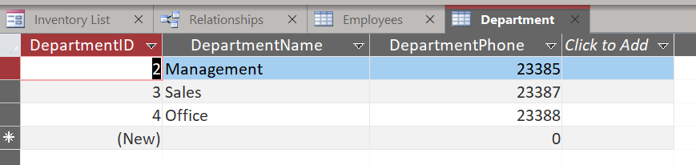

1. I list the department and role columns onto the employees table  
   Graphical user interface, text, application, email

   Description automatically generatedTable

   Description automatically generated with medium confidenceTable

   Description automatically generatedGraphical user interface, application

   Description automatically generatedA screenshot of a computer

   Description automatically generated with low confidence
2. I create a form and subform using the form wizard, after identifying relationships.  
   A screenshot of a computer

   Description automatically generated  
   Note: Department form renamed to “Department Form” from “Department”  
   Note: relationships must be assigned to each used table  
   Graphical user interface, application, PowerPoint

   Description automatically generated